Bollywood Movies Box Office Performance

This Mini Project focuses on analyzing the box office performance of 1000 Bollywood movies. The analysis includes key metrics such as worldwide collection, net collection in India, overseas collection, budget, profit, worldwide collections to budget ratio, and the final verdict of each movie. To ensure consistency, I converted Indian rupee figures to U.S. dollars using the exchange rate of 0.0121472 as of June 2, 2023. The net collection in India represents the box office revenue after deducting taxes and distribution fees. The analysis is divided into three parts. The first part examines the top-performing movies based on their box office performance. The second part explores various figures categorized by the final verdict assigned to each movie. Finally, the third part delves into the relationship between box office performance and the assigned verdict for a closer examination.

Part I

The bar graph showcases the top 15 Bollywood movies with the highest worldwide collection. Leading the pack is "Dangal" with a staggering worldwide collection of 250 million dollars. Following closely is "Baahubali 2: The Conclusion" with an impressive collection of around 217 million dollars. Another notable movie is "RRR," released in 2022, which reported approximately 149 million dollars in worldwide collection.

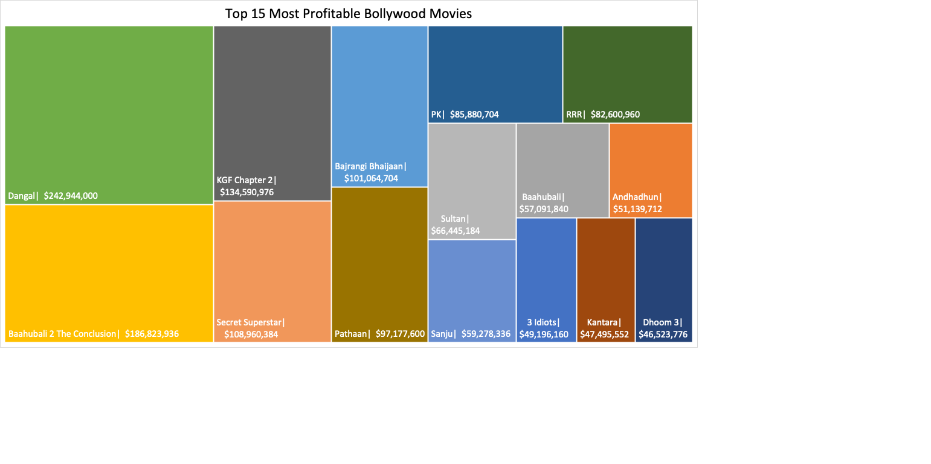

The tree map provides a visual representation of the top 15 most profitable Bollywood movies in our dataset. Notably, "Dangal," which also holds the record for the highest worldwide collection, emerges as the most profitable movie with a profit of approximately 241 million dollars. Following closely is "Baahubali 2: The Conclusion," ranking second with a profit of around 186 million dollars.It is interesting to observe that 11 out of the 15 movies with the highest worldwide collections are also included in the top 15 most profitable Bollywood movies. This indicates a strong correlation between box office success and profitability.

The vertical bar graph depicts the top 15 movies with the highest worldwide-to-budget ratio. Notably, "Ponniyin Selvan – Part 2" stands out with the highest worldwide-to-budget ratio of approximately 319. This means that the movie's collections were 319 times higher than its budget, indicating a remarkable financial success. Additionally, "Dangal" and "Secret Superstar" are also featured in this list, showcasing their strong performance in terms of generating significant worldwide collections compared to their respective budgets. The inclusion of these movies highlights their exceptional profitability and indicates a favorable return on investment in the global market.

Worldwide collection / Budget = Worldwide-to-Budget

The bar graph showcases the top 15 movies with the highest budget. Leading the list is "RRR" with a budget of approximately 67 million dollars, closely followed by "Brahmastra Part One: Shiva" and "Radhe Shyam" with budgets of around 42 million dollars each.Interestingly, six of the movies included in this list also appeared in the top 15 movies with the highest worldwide collections, indicating a significant investment in production and a potential correlation between budget and box office success

The bar graph showcases the top 15 movies with the highest budget. Leading the list is "RRR" with a budget of approximately 67 million dollars, closely followed by "Brahmastra Part One: Shiva" and "Radhe Shyam" with budgets of around 42 million dollars each. Interestingly, six of the movies included in this list also appeared in the top 15 movies with the highest worldwide collections, indicating a significant investment in production and a potential correlation between budget and box office success.

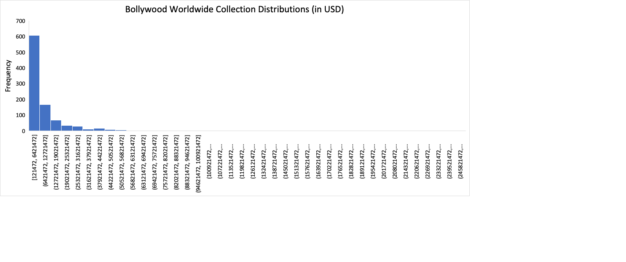

The histogram visually represents the distribution of worldwide collections among the movies in our dataset. The shape of the distribution is right-skewed, meaning that there are a few movies with extremely high collections that contribute to a long right tail on the graph.The average worldwide collection among the movies is approximately 9.53 million dollars, indicating the average performance in terms of box office revenue. The median worldwide collection, which represents the middle value in the dataset, is 4.37 million dollars, suggesting that there is a considerable range of collections among the movies.

The bin on the histogram that contains the highest number of movies, totaling 606 movies, has a range between 121 thousand and 6.42 million dollars.

Part 2

The bar graph represents the average worldwide collection categorized by verdict for the movies in our dataset. We have identified nine different verdicts, namely Flop, Hit, Average, Superhit, Disaster, Blockbuster, Below Average, Above Average, and All Time Blockbuster. Among these verdicts, the All Time Blockbuster category has the highest average worldwide collection, amounting to approximately 55 million dollars. The Blockbuster category follows closely with an average collection of around 21 million dollars. Superhit movies, on average, have a collection of approximately 14.9 million dollars.

As expected, movies that received a higher verdict, such as Blockbuster and All Time Blockbuster, performed better in terms of worldwide collection compared to movies with a poorer verdict. The graph highlights the correlation between the movie's verdict and its average collection, indicating that movies with a more favorable verdict tend to achieve higher box office success.

The graph displays the number of movies categorized by verdict.

In our dataset, we have analyzed a total of 196 movies categorized as Flop, 189 movies categorized as Hit, 112 movies categorized as Superhit, 85 movies categorized as Disaster, 73 movies categorized as Blockbuster, 68 movies categorized as Below Average, 130 movies categorized as Average, 55 movies categorized as Above Average, and 29 movies categorized as All Time Blockbuster.

Among these verdicts, it is evident that achieving the Blockbuster and All-Time Blockbuster status is relatively rare and challenging. Only a limited number of movies, specifically 73 movies classified as Blockbuster and 29 movies classified as All Time Blockbuster, were able to attain this level of success in terms of their box office performance.

The vertical bar graph represents the average profit earned by different verdicts in our dataset. Among the verdicts, All Time Blockbuster movies stand out with the highest average profit, amounting to approximately 46 million dollars. These movies have proven to be immensely successful in terms of both audience reception and financial returns.

On the other end of the spectrum, movies categorized as Disaster had the lowest average profit, indicating substantial financial losses. On average, these movies incurred a loss of approximately 3 million dollars, highlighting their poor performance at the box office. Movies classified as Flop had an average profit of around 285,000 dollars, suggesting limited success in terms of profitability. While these movies did not generate significant financial gains, they managed to recover some of their production costs. It is clear from the graph that profitability significantly impact the verdict of a movie . All Time Blockbuster movies stand out as the most profitable, while Disaster movies face significant financial setbacks.

The bar graph illustrates the average movie budgets categorized by verdict in our dataset. Among the verdicts, All Time Blockbuster movies exhibited the highest average budget, amounting to around 9 million dollars. These movies, characterized by their exceptional success, often receive substantial investments to ensure high production values and engaging storytelling.

Interestingly, Above Average movies had the lowest average budget, indicating that movies with moderate success can achieve favorable outcomes with relatively lower production costs.

Surprisingly, Disaster movies had the second-highest average budget, approximately 6 million dollars, despite their poor box office performance. This highlights the fact that a high budget does not guarantee commercial success or critical acclaim.

The average overseas collection of All Time Blockbusters surpasses other verdicts by a significant margin, reaching approximately 20 million dollars. In contrast, flop, above average, and disaster movies exhibit the lowest average collections in terms of overseas revenue ranging from around 670K to 843K. The overseas market and its audience play a crucial role in determining the overall success and profitability of a movie at the box office.

The bar graph illustrates the average net collection in India across different verdicts. All Time Blockbuster movies, on average, generated the highest net collection at approximately 20.3 million dollars. In contrast, flop and disaster movies had much lower average net collections, around 2.5 million and 2 million respectively. The Indian market holds significant importance in determining the overall collection of Bollywood movies.

Part III

For the subsequent analysis, I created a verdict rating column to examine the correlation between the verdicts and the numerical variables in our dataset. With a total of 9 different verdicts in the verdict column, I assigned a unique number to each verdict. The objective was to assess the impact of a movie's box office performance on its verdict.

Disaster – 0

Flop – 1

Below Average – 2

Average – 3

Above Average – 4

Hit – 5

Superhit – 6

Blockbuster – 7

All time Blockbuster – 8

Correlation: 0.80

The Scatterplot illustrates the correlation between the verdict rating and the average profit of Bollywood movies. With a correlation coefficient of 0.80, we observe a strong positive relationship between these two variables. The correlation implies that the average profits of a movie have a significant influence the verdict. On average, movies with a disaster verdict recorded losses of approximately 2.64 million dollars. In contrast, movies labeled as All-Time Blockbusters generated an average profit of 46.9 million dollars. As we progress from the disaster verdict to the All-Time Blockbuster verdict, there is a consistent increase in average profits, excluding the above-average movies.

The graph depicts the association between the verdict rating and the average net collection in India for Bollywood movies. With a correlation coefficient of 0.84, we observe a strong positive relationship between these two variables. This indicates that the net collection in India significantly influences the verdict assigned to movies, aligning with our expectations. Notably, the correlation between net collection in India and verdict rating is slightly stronger than the relationship between average profits and verdict rating. It is evident that movies earning higher net collections in the Indian market tend to receive more favorable verdicts. On average, movies with a disaster verdict garnered approximately 2 million dollars in net collection, while All-Time Blockbuster movies achieved an average net collection of around 20.3 million dollars.

Correlation: 0.691

The Scatterplot illustrates the relationship between the average overseas collection and the verdict assigned to Bollywood movies. With a correlation coefficient of 0.69, there is a notable and moderately strong association between these variables.

On average, movies with a disaster verdict generated an overseas collection of approximately 843K, while All-time Blockbuster movies achieved an impressive average of around 18.9 million dollars. It is worth mentioning an interesting observation in the scatterplot: a distinct data point corresponds to the verdict rating 4, representing "Above Average." Surprisingly, movies with this verdict, on average, generated less overseas collection compared to movies with an "Average" verdict by nearly 57%.

Correlation: 0.283

The scatterplot showcases the relationship between the verdict assigned to Bollywood movies and their average budget. The objective was to examine whether the budget had any influence on the earnings and subsequent verdict of a movie.

The correlation between the variables was found to be 0.28, indicating a weak positive relationship. This suggests that the budget of a movie is not a strong determinant of its performance or verdict. Other factors may play a more significant role in determining a movie's success. Interestingly, movies with a disaster verdict had an average budget of approximately 6.249 million dollars, which exceeded the budgets of most movies except for All-time Blockbusters. This implies that a higher budget does not necessarily guarantee a favorable verdict. In fact, a higher budget may increase the risk of receiving a poor verdict, as the movie needs to generate a higher collection to be deemed successful. On the other hand, movies that attained an All-time Blockbuster verdict had the highest average budget among the verdicts, with an average of 8.19 million dollars. This suggests that while a higher budget may not guarantee success, it may still be a contributing factor for movies that achieve exceptional performance.

Based on the analysis conducted, it can be concluded that the Indian net collection, overseas collection, and average profits are strong predictors of the verdict assigned to Bollywood movies. These variables have a significant impact on the final verdict, indicating that the box office performance plays a crucial role in determining the success and reception of a movie.

The correlation analysis supports this conclusion, with strong positive correlations observed between the verdict and variables such as net collection in India, overseas collection, and average profits. This implies that movies with higher box office earnings are more likely to receive favorable verdicts, such as Hit, Superhit, Blockbuster, or All-time Blockbuster.

Source: <https://www.kaggle.com/datasets/bilalwaseer/top-1000-bollywood-movies-and-their-box-office>